**CN5006 Lab Session Week 4 Portfolio**

**Prepared by:Radhe Shyam Yadav  
Date: *22-oct-2024***

**Module:** Web and Mobile Application Development  
**Lab Prepared By:** Dr. Nadeem Qazi

**Lab Objectives**

This lab session focused on understanding and implementing the following concepts:

1. Creating an Express application using Node.js.
2. Using GET methods to create RESTful API endpoints.
3. Handling parameters using req.param and req.params.
4. Reading data from a JSON file using Node.js modules.
5. Submitting data via a POST request and parsing it with body-parser.

**Lets start task and implementation setup the project.**

For the week 4 I followed the module guideline so that I need to create new folder named week4labsession and navigate it in visual studio code and the I nee check if my machine has node.js installed or not with cmd npm init -y which create package .json and for the installation for the express with cmd npm install express –save.

Here I put the screenshot for the confirmation of installed the node.js and installed express

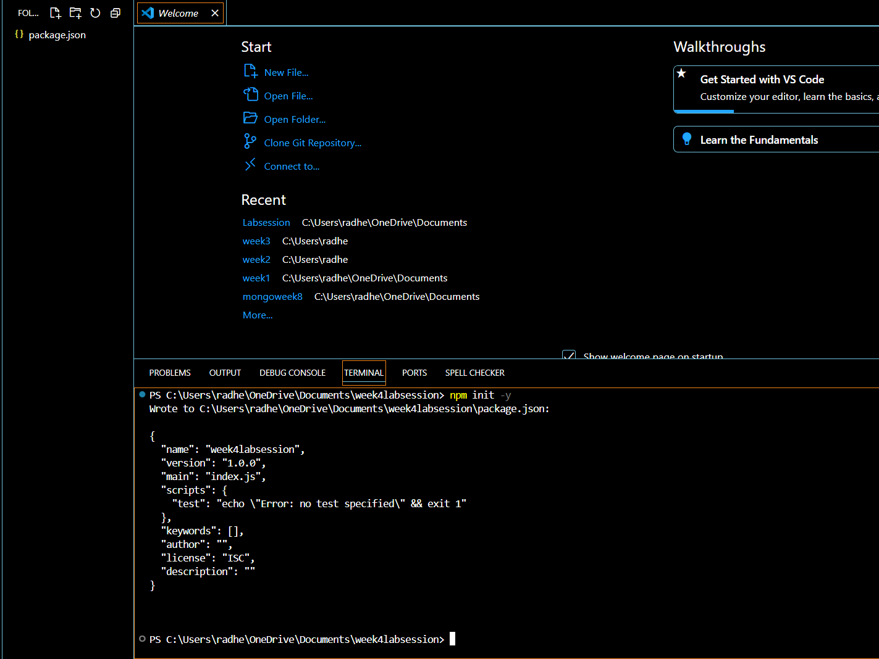

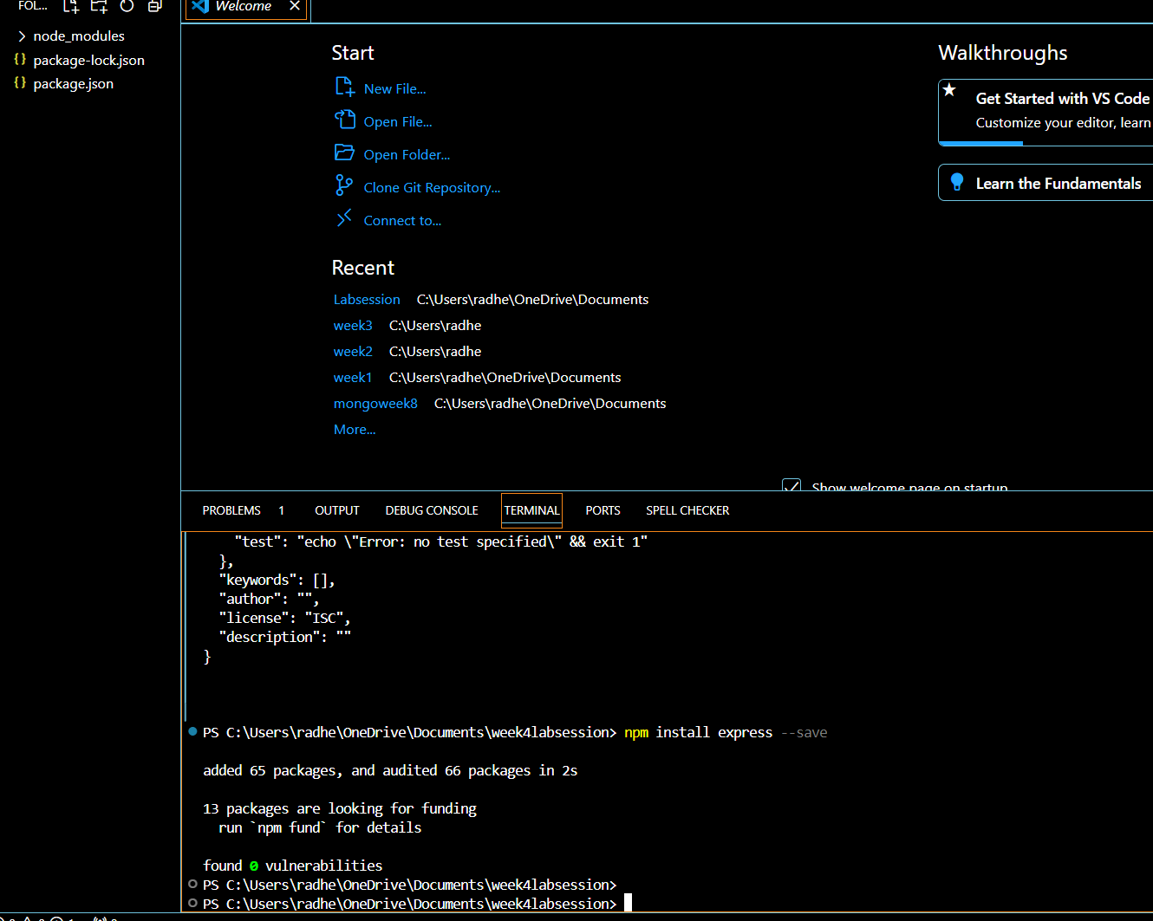

**Task 1**: Basic Express Application

**Code Implementation**

Here it showing server is running on port 5000

It should display: “Hello, this is my first Express application”.